

|  |  |
| --- | --- |
|  | Laboratory Exercise 3: Standardized Tensile Testing |
|  |  |
|  | Nguyen Xuan Binh (887799)  Talha Waqar (101561697) |
|  | MEC-E6007 Mechanical Testing of Materials  14/05/2024 |
|  |  |

**Symbols**

|  |  |  |
| --- | --- | --- |
| **Symbol** | **Unit** | **Designation** |
| b0 | (mm) | Original width |
| a0 | (mm) | Original thickness |
| Lc | (mm) | Parallel length |
| S0 | (mm2) | Original cross-sectional area |
| Lu | (mm) | Final Gauge length |
| L0 | (mm) | Original gauge length |
| vc | (mm/min) | Crosshead separation rate |
| é | (1/mm) | Strain rate |
| σ | (MPa) | Stress |
| e | (mm) | Strain |
|  | % | Percentage elongation after fracture |
|  | (GPa) | Young’s modulus |

# Introduction

In this report, a tensile test is conducted in the material testing laboratory by two students from the Materials Testing of Materials course. Specifically, this laboratory exercise also provides knowledge about materials properties, such as elasticity, plasticity, stiffness, strength, and ductility. Before the test, instructions for the laboratory were given based on ISO 6892-1:2016 A224 metallic materials standard to help students familiarize themselves with the standardized methods for conducting the test. It was recommended that the specifications of the tensile test should be studied before the laboratory, such as the dimension of the specimen. The tasks were to carry out tensile test for one test sample, whose detailed material properties were not given except that it is Aluminum of grade 5000. Naturally its materials can be obtained online, but this lab helps us verify if the test results match those referenced standard material properties.

Tensile test is used for measuring material’s ability to resist the tension force, which is applied to the test specimen by connecting it to a tensile testing machine, which in this case was MTS Insight Electromechanical – 30kN Standard length tensile testing machine. The dimensions of the test specimen are set to the machine, in addition to the crosshead separation rates calculated according to the standard. The tensile test machine gives force-elongation curve, from which different kinds of information from the material can be interpreted, such as elastic modulus, yield strength, tensile strength and fracture point. These values describe how much the material elongates with certain amount of stress, how much stress is needed to deform the material permanently, what is the maximum amount of stress the specimen can resist and the point when the specimen fractures. These characteristics of the material are important to know, for example when estimating, how much load a certain structure can hold safely.

From the manual principle, the test involves straining a test piece by tensile force, generally to fracture, for the determination of one or more of the mechanical properties. The test shall be carried out at room temperature between 10 °C and 35 °C, unless otherwise specified. When testing and calibration activities are performed outside the recommended temperature limits of 10 °C and 35 °C, the temperature shall be recorded and reported. If significant temperature gradients are present during testing and or calibration, measurement uncertainty may increase and out of tolerance conditions may occur.

Tests carried out under controlled conditions shall be made at a temperature of 23 °C ± 5 °C.

# Standardized tensile testing

**2.0 Some terminology clarification**

The laboratory experiment uses several tools, and we must define specifically what properties they are capable of measuring and how they measure strains in the Universal Testing Machine

* Extensometer:

An extensometer is a device used to measure changes in the length of an object. It is specifically designed to measure the deformation (strain) of test specimens when a load is applied. Extensometers are very accurate and can measure very small changes in length. They are typically clamped to the sample and provide direct measurement of the deformation, allowing for detailed analysis of strain at various stages of a test.

* Strain gauge:

A strain gauge is a sensor whose resistance varies with applied force; it converts force, pressure, tension, weight, etc., into a change in electrical resistance which can then be measured. Strain gauges are bonded directly to the material of the specimen and can measure the strain over a very small or localized area. They are widely used because of their precision and the fact that they can be attached to almost any material type.

* Crosshead:

The crosshead is part of a universal testing machine which moves during a test, applying the load to the specimen. It generally moves at a controlled rate to stretch or compress the specimen. The displacement of the crosshead provides a measure of the overall deformation of the specimen. This measurement, however, is not as precise for strain measurements as those from an extensometer or a strain gauge, because it includes any bending of the machine or slippage in the grips in addition to the actual deformation of the specimen.

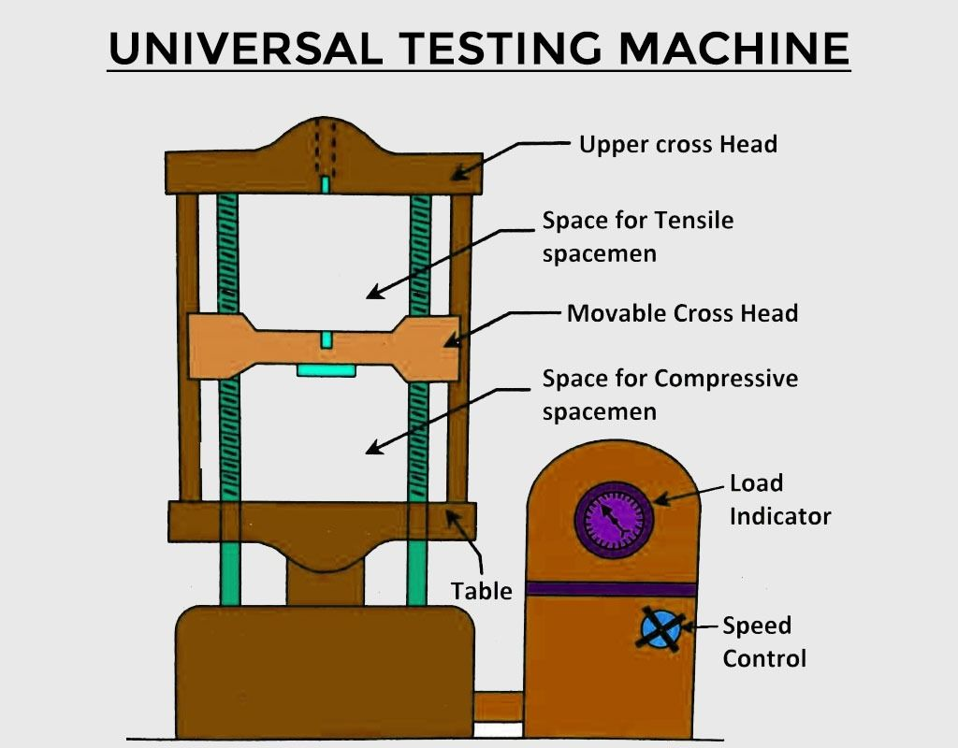

Question: Why are extensometers needed in tensile tests? Can't we simply determine the elongation by distance = speed x time since we know the speed the grips are moving?

Answer: Load frames can measure crosshead displacement. However, many tests use “dog bone” specimens which have non constant cross-section (which is our case). Then it is useful to use an extensometer to measure the elongation of just the specific section.

In general, extensometers are used whenever you want to measure the elongation of a local section of the specimen, not just the global elongation like the crosshead does.

**2.1 Strain gage setup**

From the Kyowa manual [1], strain gages are designed to electrically detect “strain,” minute mechanical changes occurring in response to applied force. They are used not only for machines and moving objects but also in various fields including electrical equipment, civil engineering, building construction, chemicals and medicine. Strain gages enable detection of imperceptible elongations or shrinkages occurring in structures. Measurement of such elongations or shrinkages reveals the stress applied to the structure. Stress is an important factor to confirm the strength and safety of structures.

Kyowa strain gages are available for measurement of varied types of strain, from static strain to dynamic strain occurring at higher than 100 kHz and impact-initiated strain. Kyowa strain gages also provide a wide range of applications and can conveniently be applied to structures of varied materials and shapes.

In addition, strain gages are used as sensing elements for measuring load, pressure, acceleration, displacement, and torque. Thus, they are widely utilized not only in experiments and research but also for industrial measurement and control.

The strain gage used in this report is from Kyowa manufacturer. It is a biaxial strain gauge capable of measuring strains in X and Y direction, whose brand code is KFGS-5-120-C1-11 L1M2R.

From the package, there are usually two pieces of information that we should pay attention to: the gage length (5 mm) and the Applicable Adhesive (CC-33A, EP-340). The gauge length of a strain gauge, in this case, 5 mm, refers to the active length over which strain is measured, indicating the segment of the sensor that detects mechanical changes. The applicable adhesive, such as CC-33A or EP-340, is the recommended bonding agent used to securely attach the strain gauge to the test specimen, ensuring accurate strain measurement. Using the wrong glue type can result in erroneous measure as the strain gage is not tightly glue to the surface. Below is the manual of applying strain gage onto the tensile specimen

**How it works (IMPORTANT): the extensometer measures strain along y direction, and the strain gauge will measure strain along x direction. Together we can capture the axial and longitudinal strain and derive values such as Poisson’s ratio.**

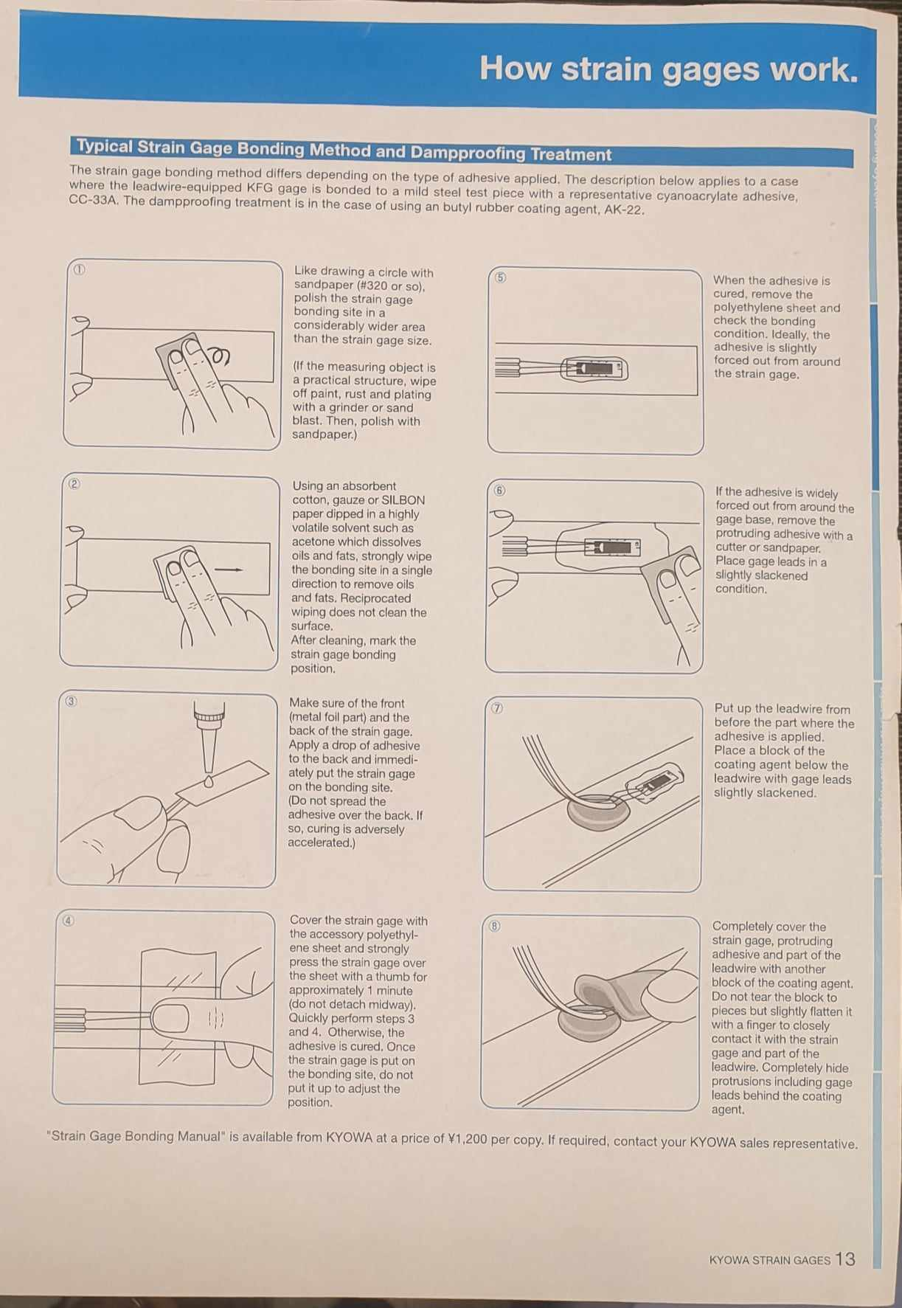

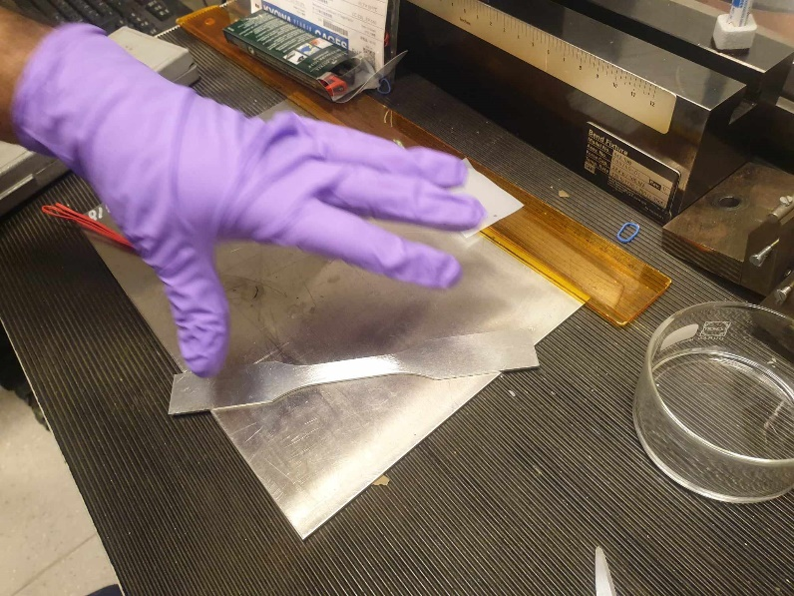

According to the manual, we use some white sandpaper and dip them little inside the glue liquid (glue is contained in the transparent bowl in the image above). Then, we proceed to clean the middle part of the specimen until the middle part becomes polished and bright, and the sandpaper no longer is tainted with dirt.

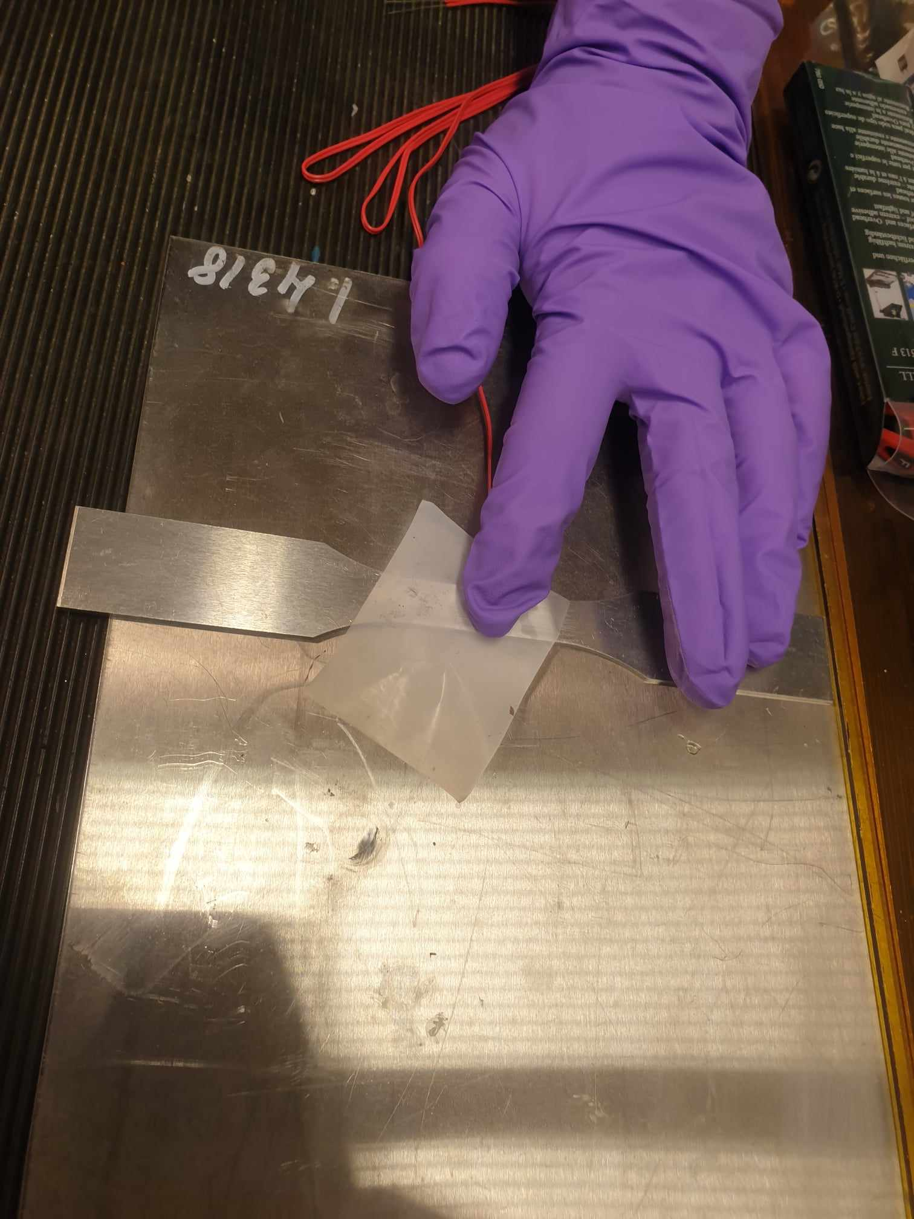

Next, we would pour one small drop of adhesive glue on the strain gage, and we press the strain gage tightly on the specimen for one minute to ensure that the strain gage is glued properly and does not vibrate during tensile test. Use paper to ensure that our hand do not come into contact with the adhesive glue. We need to glue the correct face of the strain gage on the specimen; otherwise, we need to restart the whole process and the strain gage is also not trivially cheap.

Finally, we release, and the strain gage is now properly glued to the specimen.

**2.2 Tensile specimen dimension**

Prior to conducting the tensile tests, the dimensions of the specimens were measured using a caliper and a plastic ruler. The widths and thicknesses of the specimens were measured with the caliper at three points on the tapered parts of the specimens, close to the middle and near both ends. The gauge length was marked on the specimen with a marker and measured with the ruler to be 50.5 mm, as is said in the standard’s annex B. Also, the parallel lengths were measured with the ruler. Measurements are presented in tablebelow; the original cross-sectional areas were calculated from multiplying original width and original thickness

|  |  |
| --- | --- |
| **Sample dimension** | **Measurement** |
| Original width, b0 (mm) | 12.12 mm |
| Original thickness, a0 (mm) | 1.95 mm |
| Original gauge length, L0 (mm) | Not measured |
| Parallel length, Lc (mm) | 50.50 mm |
| Original cross-sectional area, S0 (mm2) | 23.634 mm2 |
| Final gauge length, Lu (mm) | Not measured |

* 1. **Strain rate determination**

In accordance with the SFS EN ISO 6892-1:2019 manual page 32, during tensile testing, we choose a strain rate of range 2 for both elastic regime and plastic regime, with strain rate of plastic regime twice faster than that of elastic one. This adjustment in strain rate is typical; a slower rate is used during the elastic portion of the test to ensure accurate measurement, followed by an increased rate to expedite the experiment once the material reaches its plastic deformation stage. This could help save time while not compromising accuracy of plastic measurement

To convert the strain rate of 0.00025 1/s to a more practical unit, we multiply it by the parallel length of 50.50 mm, resulting in a rate of 0.0125 mm/s. Converting this to a per minute rate, we get 0.75 mm/min. Thus, the first stage of the test is conducted at 0.75 mm/min (which typically corresponds to elastic part). In the second stage, the strain rate is increased twice to 1.5 mm/min.

Finally, we put all necessary information into the controller settings

Test speed = 0.75 mm/min

Test speed secondary = Test speed x 2 = 1.5 mm/min

Width = 12.12 mm, Thickness = 1.95 mm

VAR1 is the percentage where we would increase the test speed gradually from first to secondary stage. Additionally, we do not zero out the load as the specimen is already subject to stress due to gripping. Zeroing out the stress would make stress measurement offset slightly, which is undesirable in our case.

* 1. **Setting specimen on the tensile machine**

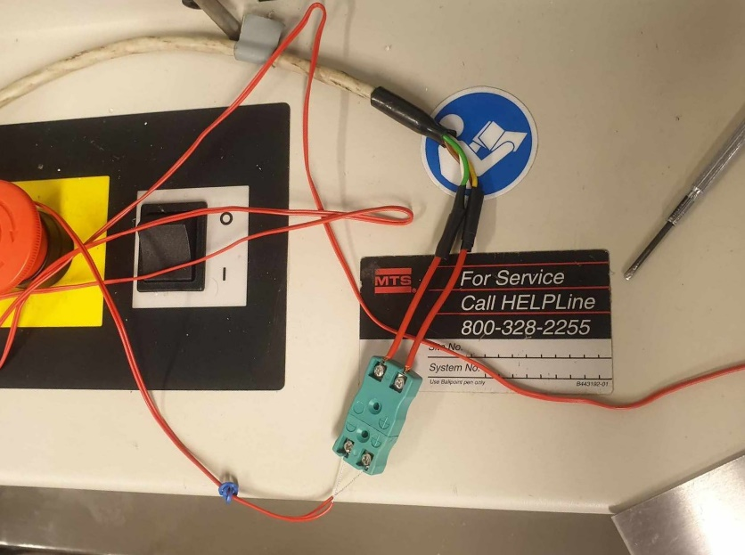

The sample was then mounted onto the grips of the testing machine, affixing it there tightly to give good attention for correct alignment and grip setting. This is done to ensure that force applied is uniformly distributed over the specimen thereby minimizing pre-mature failure or bogus measurements. Correct gripping adjustments guarantee that throughout the test, the sample remains in its position thus avoiding slipping or misalignment. At this stage, one must be very careful to obtain dependable and uniform results from the tensile test.

For the tensile tests, the data is collected using the MTS Insight Electromechanical – 30kN Standard length tensile testing machine together with MTS extensometer. The specimen was firmly mounted within the testing machine’s grips on their turn, with meticulous attention to proper alignment and grip adjustment.

After that, we proceed to run the tensile test. Both the extensometer and the strain gages are synchronized to measure instantaneous axial and longitudinal strain

For example, SG signal is negative suggesting that the specimen width is thinning, which is expected as metals always becomes thinner under tensile test leading to positive Poisson ratio.

* 1. **Specimen fractures**

The specimen, however, deformed in the course of its tests until it achieved its ultimate tensile strength, thereafter it broke. Fracture behavior of the specimen is an important method of gaining insights into mechanical properties and performance under uniaxial tension. Ductility, brittleness and fracture mode are some of the fracture features that can be observed from visual examination of the surface (shear, cleavage or dimpled). This also helps researchers and engineers to understand material behavior among other things like identifying failure mechanisms and optimize material selection for different applications. Moreover, fractographic analysis can be done through method such as scanning electron microscopy (SEM) to further probe microstructures and causes of breakdown in materials.

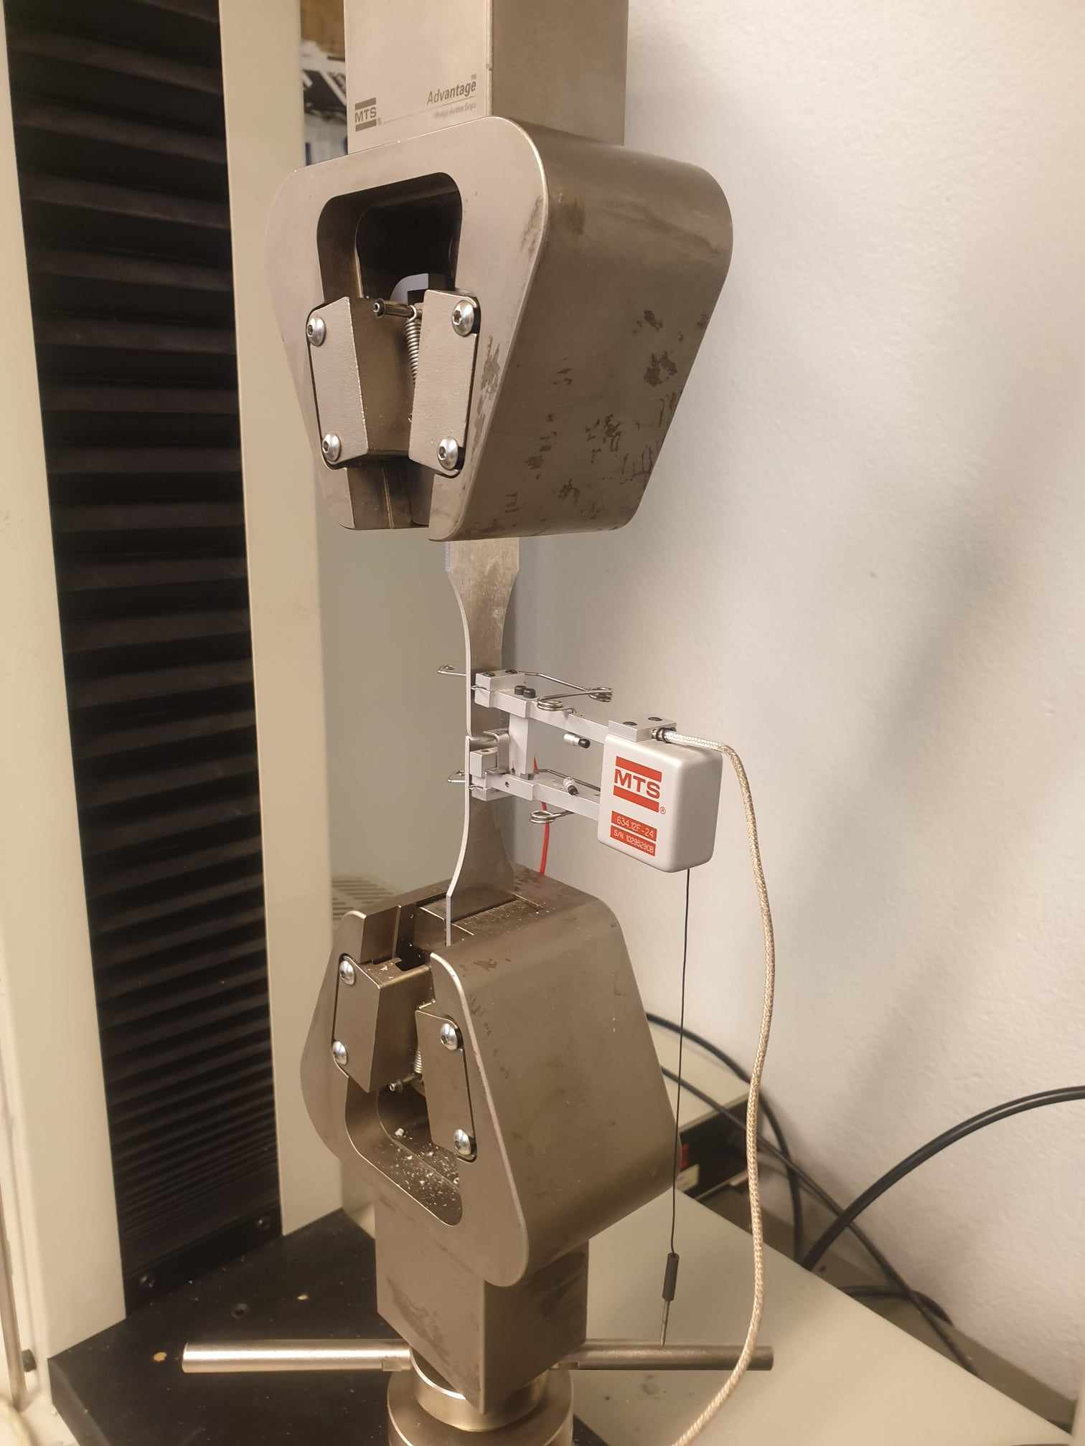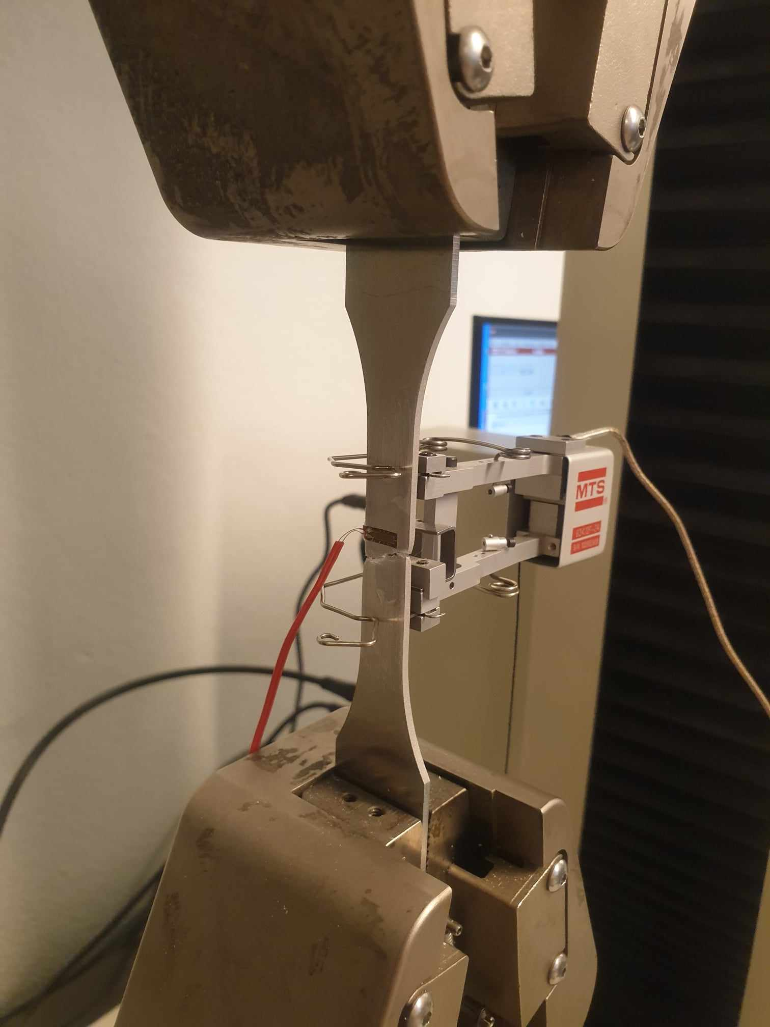

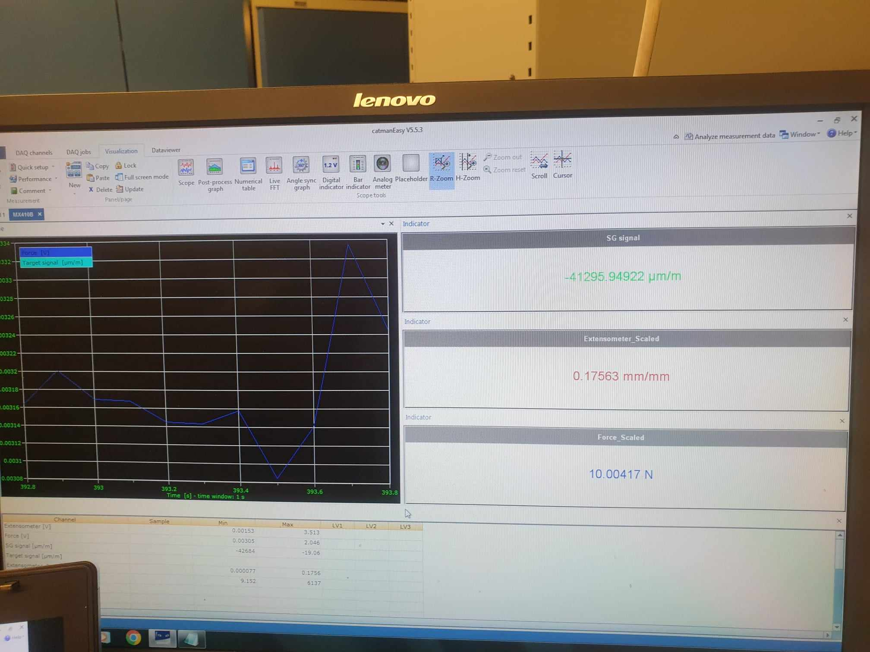

Material finally fractures after axial strain of 0.17563 and the corresponding scaled force is 10 N

The machine plots preliminary result for us to record. However, we would obtain the material properties systematically in the result section

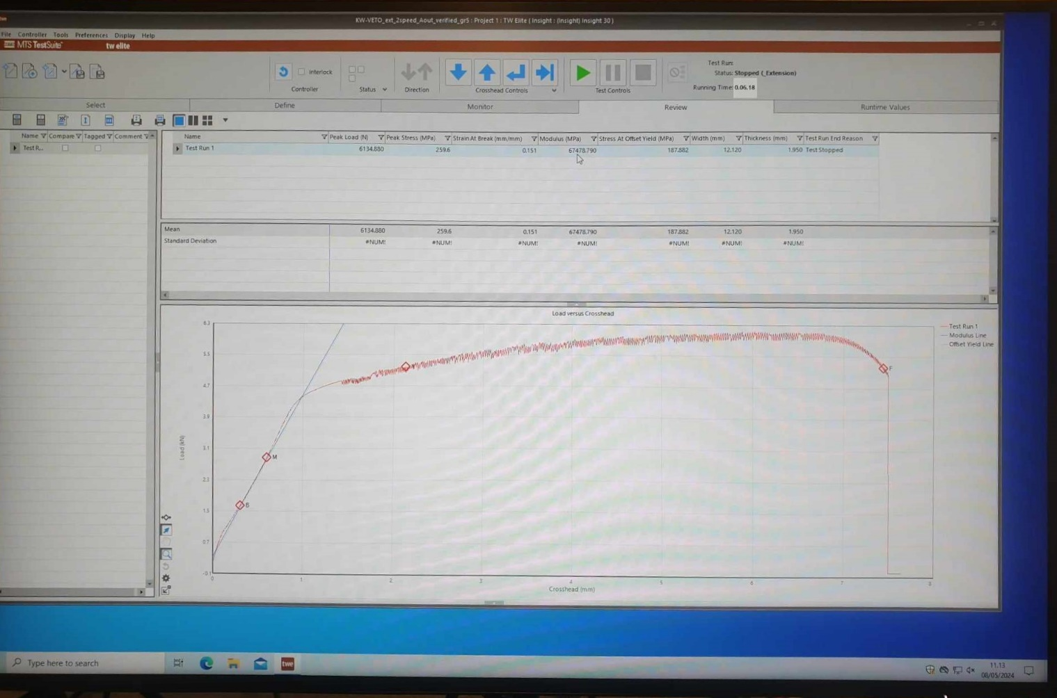

# Results

**3.1 Data from strain gage**

In Python, we can extract the exported data, which have 5 columns as noted below

aluminum_strain_gage = pd.read_csv('aluminum_strain_gage.csv', sep='\t', index_col=False)

time_strain_gage = aluminum_strain_gage['Time [s]']

extensometer_strain_gage = aluminum_strain_gage['Extensometer [V]']

force_strain_gage = aluminum_strain_gage['Force [V]']

SG_signal_strain_gage = aluminum_strain_gage['SG signal [microm/m]']

extensometer_scaled_strain_gage = aluminum_strain_gage['Extensometer_Scaled [mm/mm]']

force_scaled_strain_gage = aluminum_strain_gage['Force_Scaled [N]']

- Time [s]: Time elapsed during the test, which allows correlation of force and strain data over the test duration.  
- Extensometer [V]: Voltage output from the extensometer, which represents axial strain in the Y direction (requires conversion to strain units).  
- Force [V]: Voltage output from the load cell, which represents the applied force (requires conversion to Newtons).  
- SG signal [microm/m]: measuring longitudinal strain (microstrain) from the strain gauge. It captures strain in the X direction, perpendicular to the extensometer's measurement.  
- Extensometer_Scaled [mm/mm]: Scaled strain from the extensometer, which provides direct measurement of axial strain in the Y direction.  
- Force_Scaled [N]: Force applied to the specimen, directly used for force-displacement or force-strain analysis.

**3.2 Data from extensometer**

In Python, we can extract the exported data, which have 4 columns as noted below

aluminum_extensometer = pd.read_csv('aluminum_extensometer.csv', sep='\t', index_col=False)

crosshead_extensometer = aluminum_extensometer['Crosshead [mm]']

load_extensometer = aluminum_extensometer['Load [N]']

time_extensometer = aluminum_extensometer['Time [s]']

extensometer_extensometer = aluminum_extensometer['Extensometer [mm/mm]']

- Time [s]: Elapsed time during the test, which correlates force and displacement data to specific time points, enabling time-based analysis.  
- Crosshead [mm]: Displacement of the crosshead, which indicates overall deformation applied to the specimen during the test. Used to create force-displacement curves.  
- Load [N]: Axial force applied to the specimen. Used to create force-displacement curves.  
- Extensometer [mm/mm]: Axial strain measured by the extensometer, crucial for calculating material properties like Young's modulus and Poisson's ratio.

**3.3 Plotting figures**

To plot a force-displacement curve along the axial direction, we should use Load [N] and Crosshead [mm] from extensometer data:

Next, we can proceed to plot the engineering stress-strain curve

*# Specimen dimensions*

original_width = 12.12  *# mm*

original_thickness = 1.95  *# mm*

parallel_length = 50.50  *# mm*

*# Original cross-sectional area*

original_area = original_width * original_thickness  *# mm^2*

*# Calculate stress and strain*

stress = load_extensometer / original_area  *# Stress in MPa (N/mm^2)*

strain = extensometer_extensometer  *# Strain (dimensionless)*

The laboratory report requires that students should determine the values of mechanical properties of the material, namely, tensile strength, yield strength, Young’s modulus, Poisson’s ratio, elongation to fracture. Firstly, the referenced material properties can be obtained here in this link

<https://www.matweb.com/search/datasheet.aspx?matguid=c71186d128cd423d9c6d51106c015e8f&ckck=1>

Next, we would use established formulas to derive the values for those material properties. This is easily done in Python as follows:

*# Tensile Strength (UTS)*

UTS = max(stress)

print(f"Tensile Strength (UTS): {round(UTS, 4)} MPa")

*# Young's Modulus*

linear_region = strain < 0.002  *# Assuming linear region is below 0.2% strain*

Youngs_modulus = np.polyfit(strain[linear_region], stress[linear_region], 1)[0]

print(f"Young's Modulus: {round(Youngs_modulus, 4)} MPa")

*# Yield Strength (0.2% offset method)*

offset = 0.002

offset_line = Youngs_modulus * (strain - offset)

*# Find the intersection of the offset line and the actual stress-strain curve*

yield_index = np.argmin(np.abs(offset_line - stress))

yield_strength = stress[yield_index]

print(f"Yield Strength (0.2% offset method): {round(yield_strength, 4)} MPa")

*# Poisson's Ratio*

axial_strain = extensometer_scaled_strain_gage

transverse_strain = SG_signal_strain_gage / 1e6  *# Convert microstrain to strain*

poisson_ratio = - np.mean(transverse_strain / axial_strain)

print(f"Poisson's Ratio: {round(poisson_ratio, 4)}")

*# Elongation to Fracture*

elongation_to_fracture = max(strain[0:-80])

print(f"Elongation to Fracture: {round(elongation_to_fracture * 100, 4)} %")

Collecting the results and we can make the comparison between referenced values and experimental values for Aluminum grade 5000

|  |  |  |
| --- | --- | --- |
| **Properties** | **Referenced from**  **the internet** | **Experiment results** |
| Ultimate tensile strength(MPa) | Range: 110-590 MPa  Average: 327 MPa | 259.57 MPa |
| Yield strength (MPa) | Average 239 MPa | 188.3936 MPa |
| Young’s Modulus (MPa) | Range 68.9 - 73.0 GPa | 66.385 GPa |
| Poisson’s ratio | Average 0.331 | 0.2994 |
| Elongation to fracture | Average 11.9% | 15.1% |

Generally, the ultimate tensile strength obtained experimentally was 259.57 MPa, which falls below the referenced average of 327 MPa, but it is outside the typical range of 110-590 MPa. The yield strength recorded in the experiment was 188.3936 MPa, which is considerably lower than the referenced average of 239 MPa. For Young’s Modulus, the experimental value was 66.385 GPa, slightly under the lower bound of the referenced range of 68.9 to 73.0 GPa. The experimental Poisson’s ratio was 0.2994, also lower than the referenced average of 0.331. However, the elongation to fracture showed a more positive discrepancy, with an experimental result of 15.1%, exceeding the referenced average of 11.9%. These differences is stemmed from the fact that Aluminum Grade 5000 has lots of variations and manufactured conditions, leading to a wide range of possible values for these properties, but it is sure that the difference is no more than one order of magnitude. We can safely say that the experimental result is therefore reliable.

# Discussion and conclusions

The estimation of the measurement uncertainty can be based on absolute values or relative estimations. In the manual, the estimation according to CWA 15261–2 is based on absolute values, which results in different estimations of the respective single uncertainty budgets if the test piece dimensions, or the extensometer gauge length differs. On the other hand, the estimation according to Annex K is based on relative estimations. Additionally, the test conditions defined in the ISO 6892-1 standard should not be adjusted to account for uncertainties of measurement.

An absolute uncertainty is expressed in the same unit of measurement as its associated result. A relative uncertainty is expressed in a term relative to its associated measurement result. In this report, since the test piece dimensions differ slightly by an order of 0.01mm, it is recommended to use absolute uncertainty to measure the error of the Young’s modulus. Actual calculations of uncertainty of Young’s Modulus is not considered in the scope of this report

In conclusion, this laboratory exercise has taught students the skills to:

* Read standard manuals in mechanical testing, such as ISO 6892
* Learn to use the equipment in tensile testing, such as the extensometer, the strain gage, the tensile testing machine and the software specifications
* Learn how to record data and present scientific formulas to derive materials’ properties
* Learn how to interpret the results and correlate them with the observations.

This report summarizes the knowledge the students have gained, and it can be used as a reference so others can replicate similar experiments in the future.

# References

[1] Kyowa Strain Gage Manual